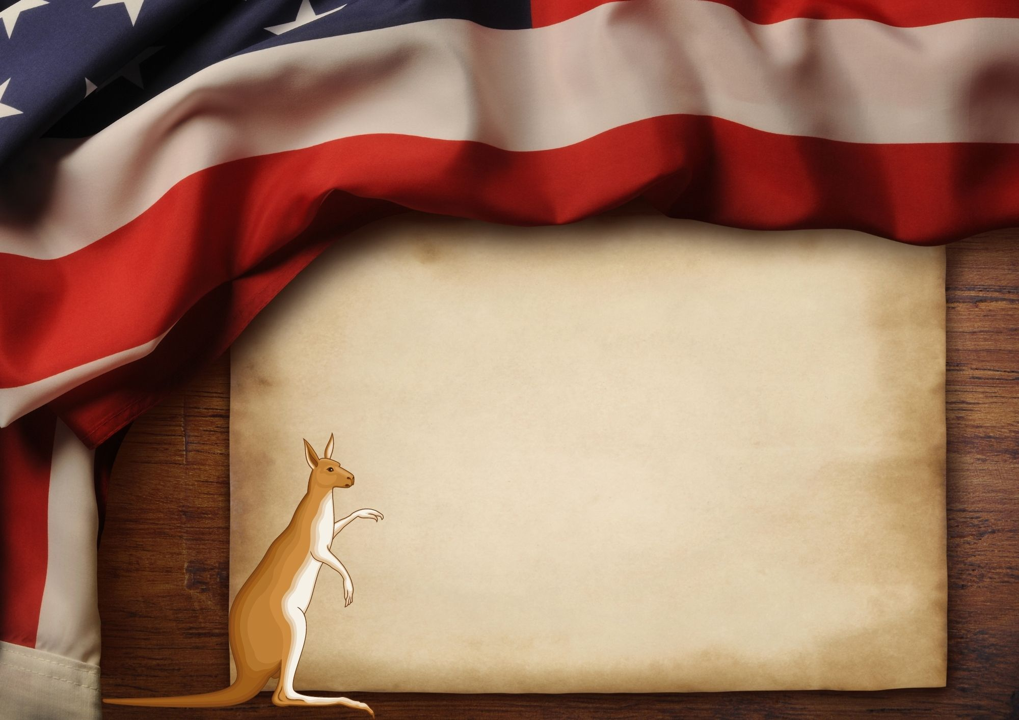

January 26th

**Join us for an afternoon from 2pm to 8pm**

**Free Drinks, Parking Slots Available**

**781 King Street, Mathew**

**Charolette-123456789**

**abc@zmail.com.au**

www.alldownunder.com

Happy

Australia Day