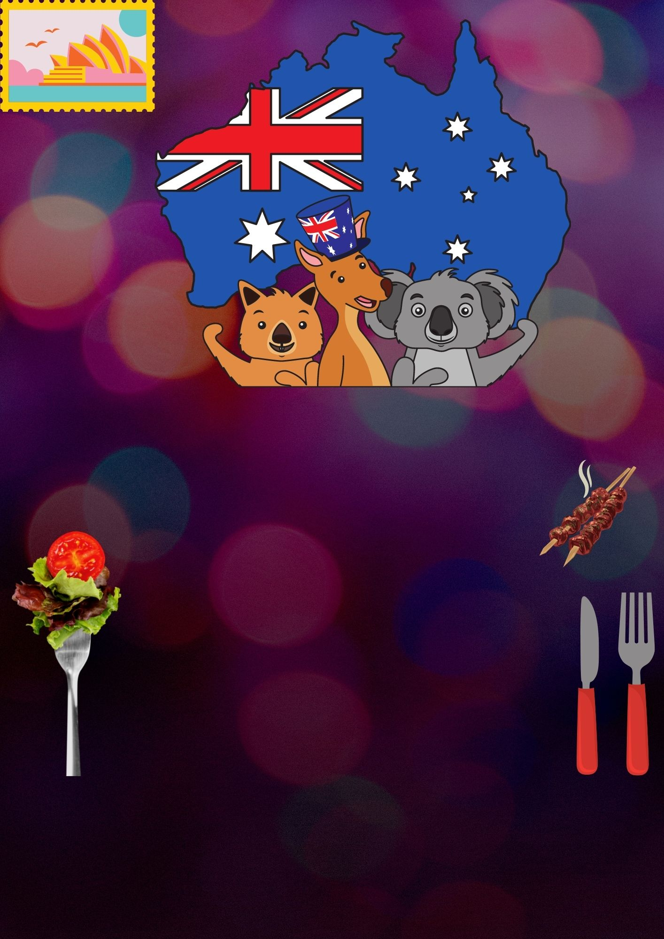

www.alldownunder.com

William

123456789

**26th January**

**2.00 PM to 9.00 PM**

Food|Fun|Celebrate

Australia Day

