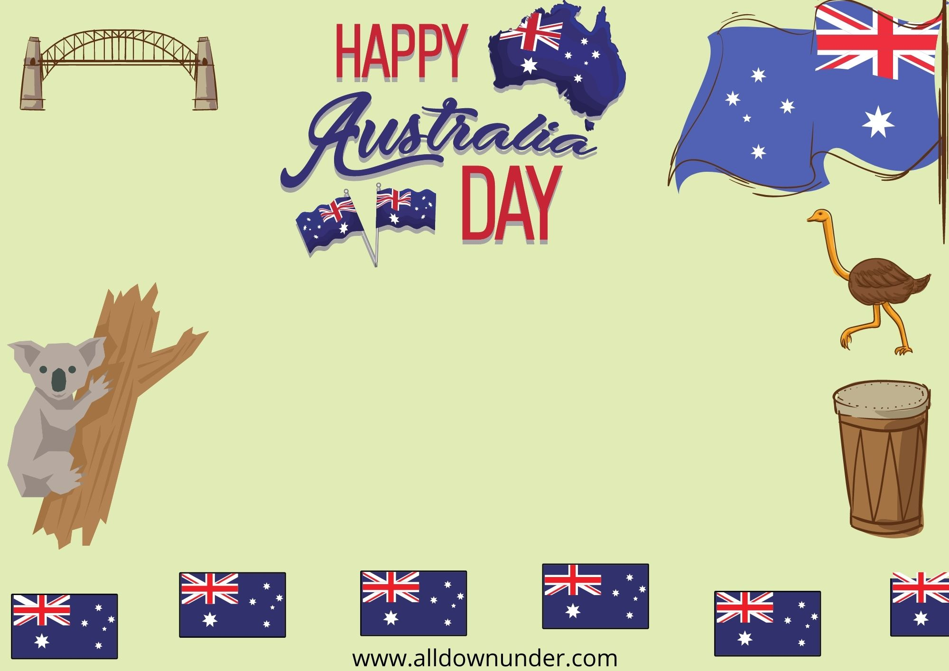

Sunday 27th January10.30AM-3.00PM

Aussie BBQ|Free Beer+Wine|Music

548Town’s Shopping Street,Sydney.

Lucy-123456789

For More Info:www.abcd.com

BBQ 2022