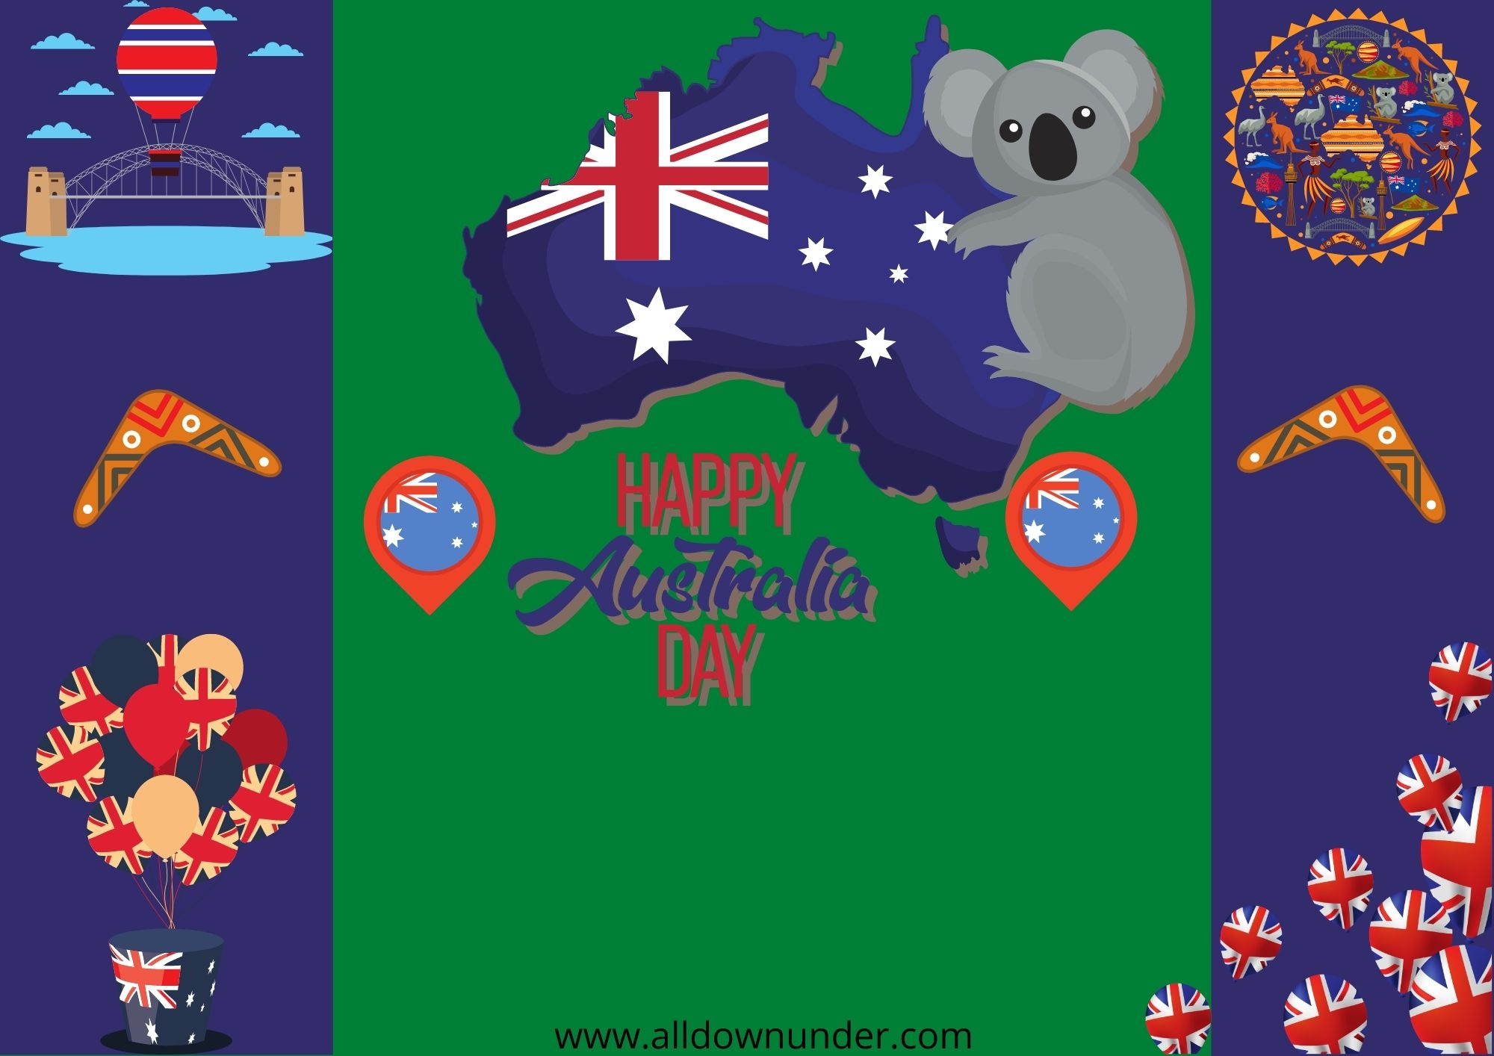

Saturday 26th January

10.30AM-3.00PM

For More Info:www.australia.com