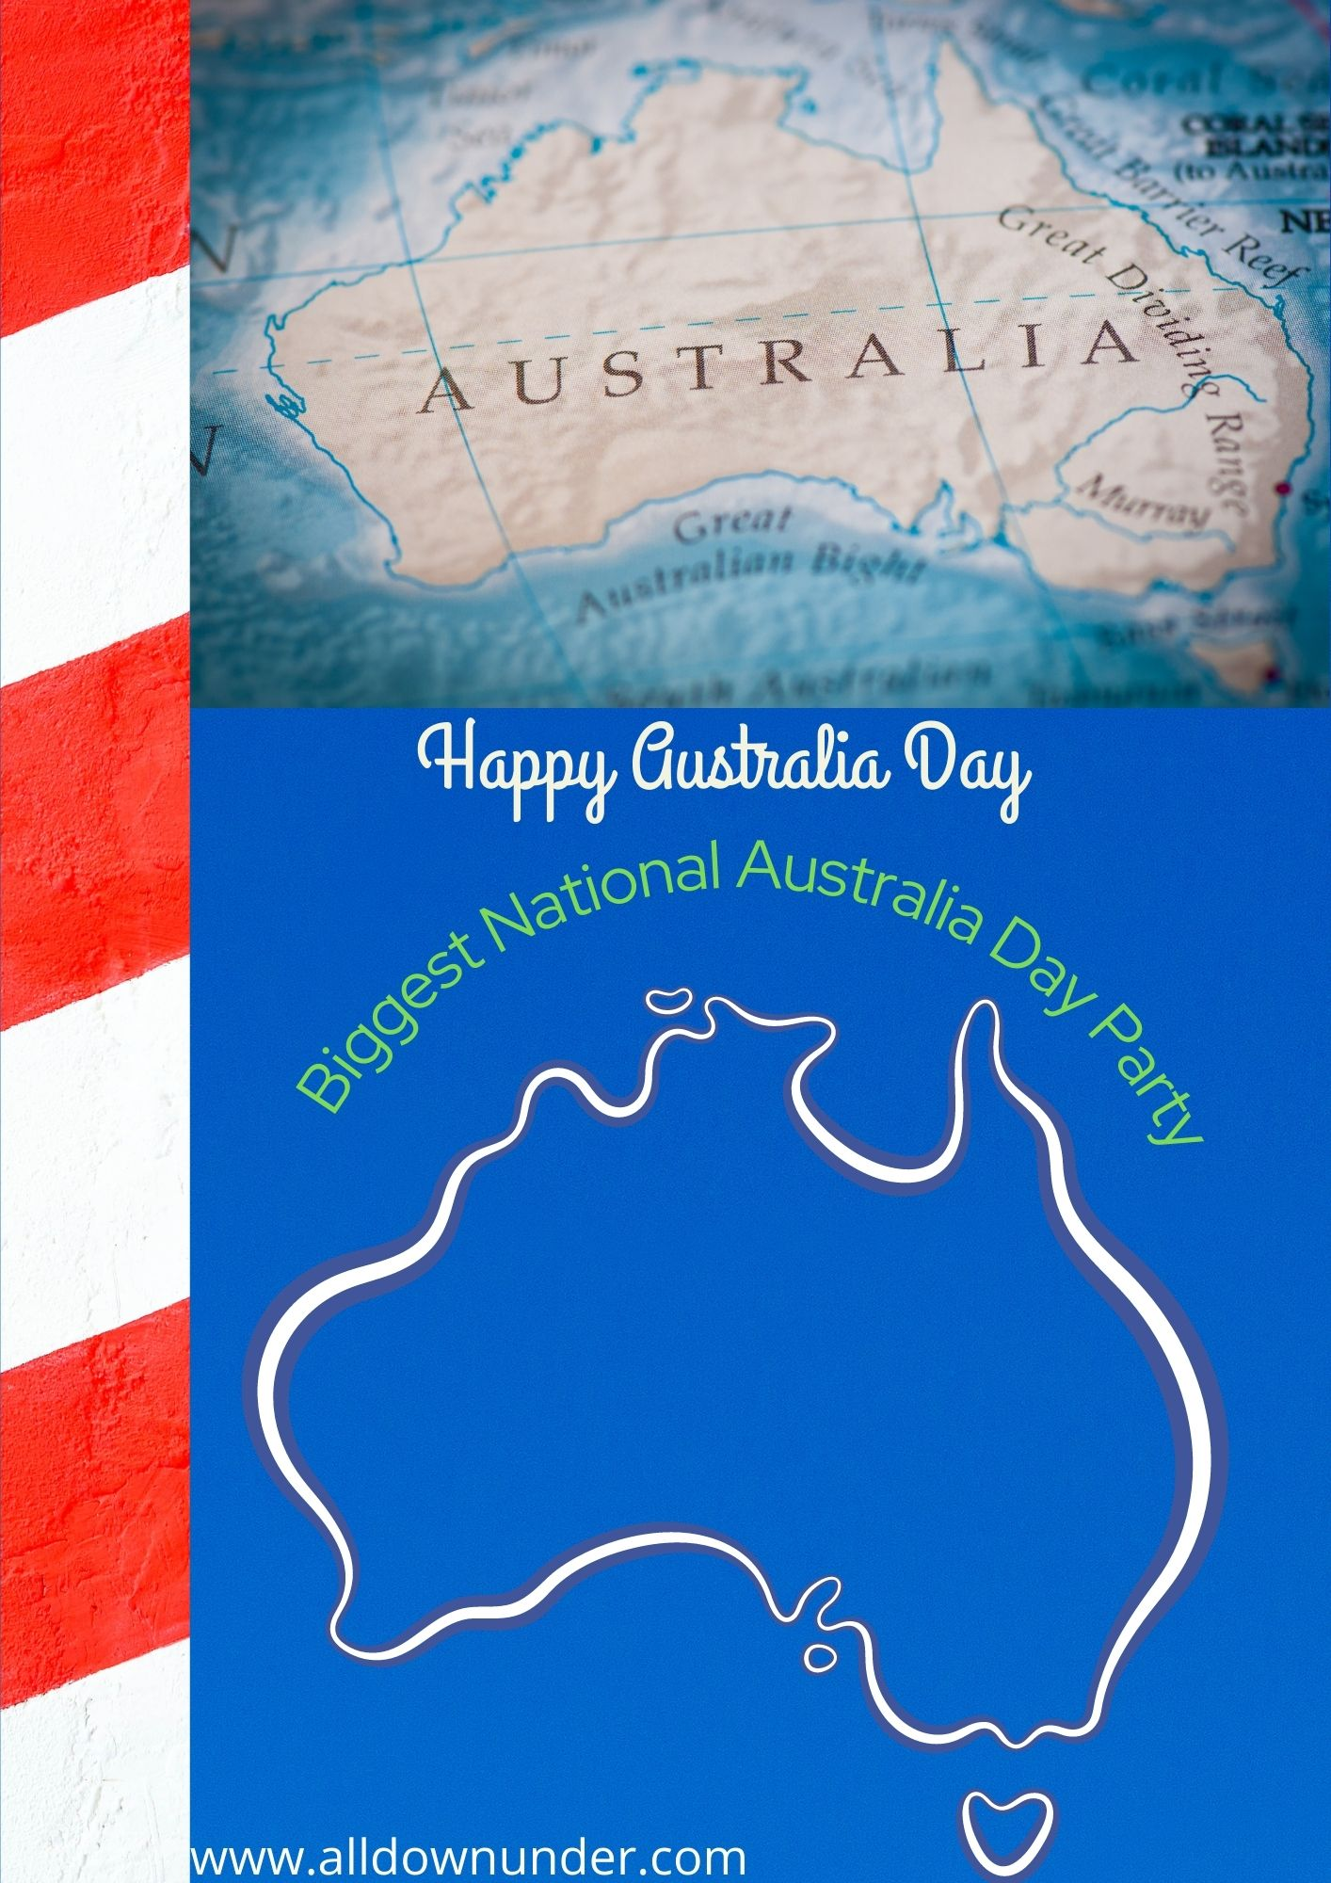

**Games|Fun|Activity|Entertainment**

Isla

12345678789

www.australiaday.com

**Australia**

**Australia**

26th January 20__