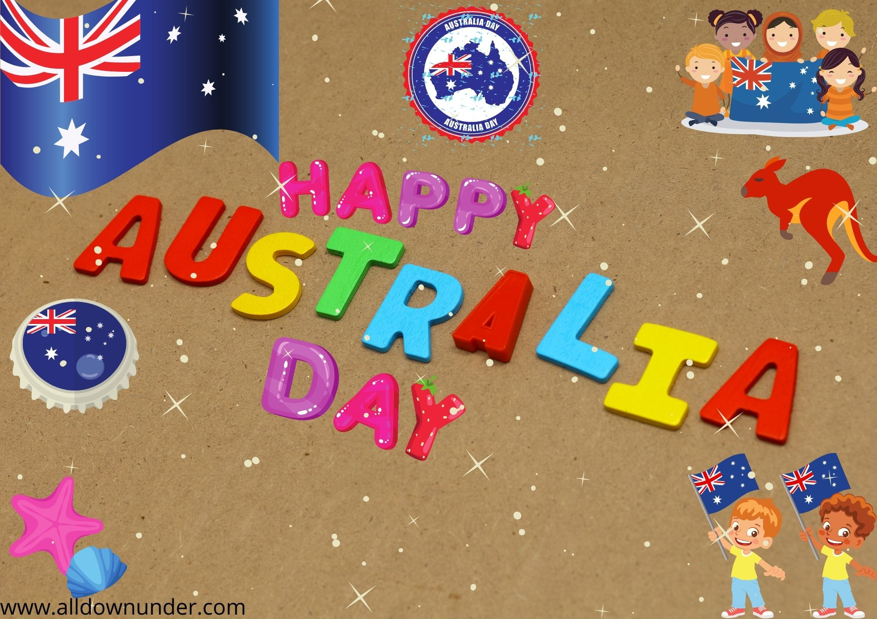

**On 26th January 3pm onwards**

4879George Street, Melbourne

Aria-123456789 or Rsvp: abc@zmail.com