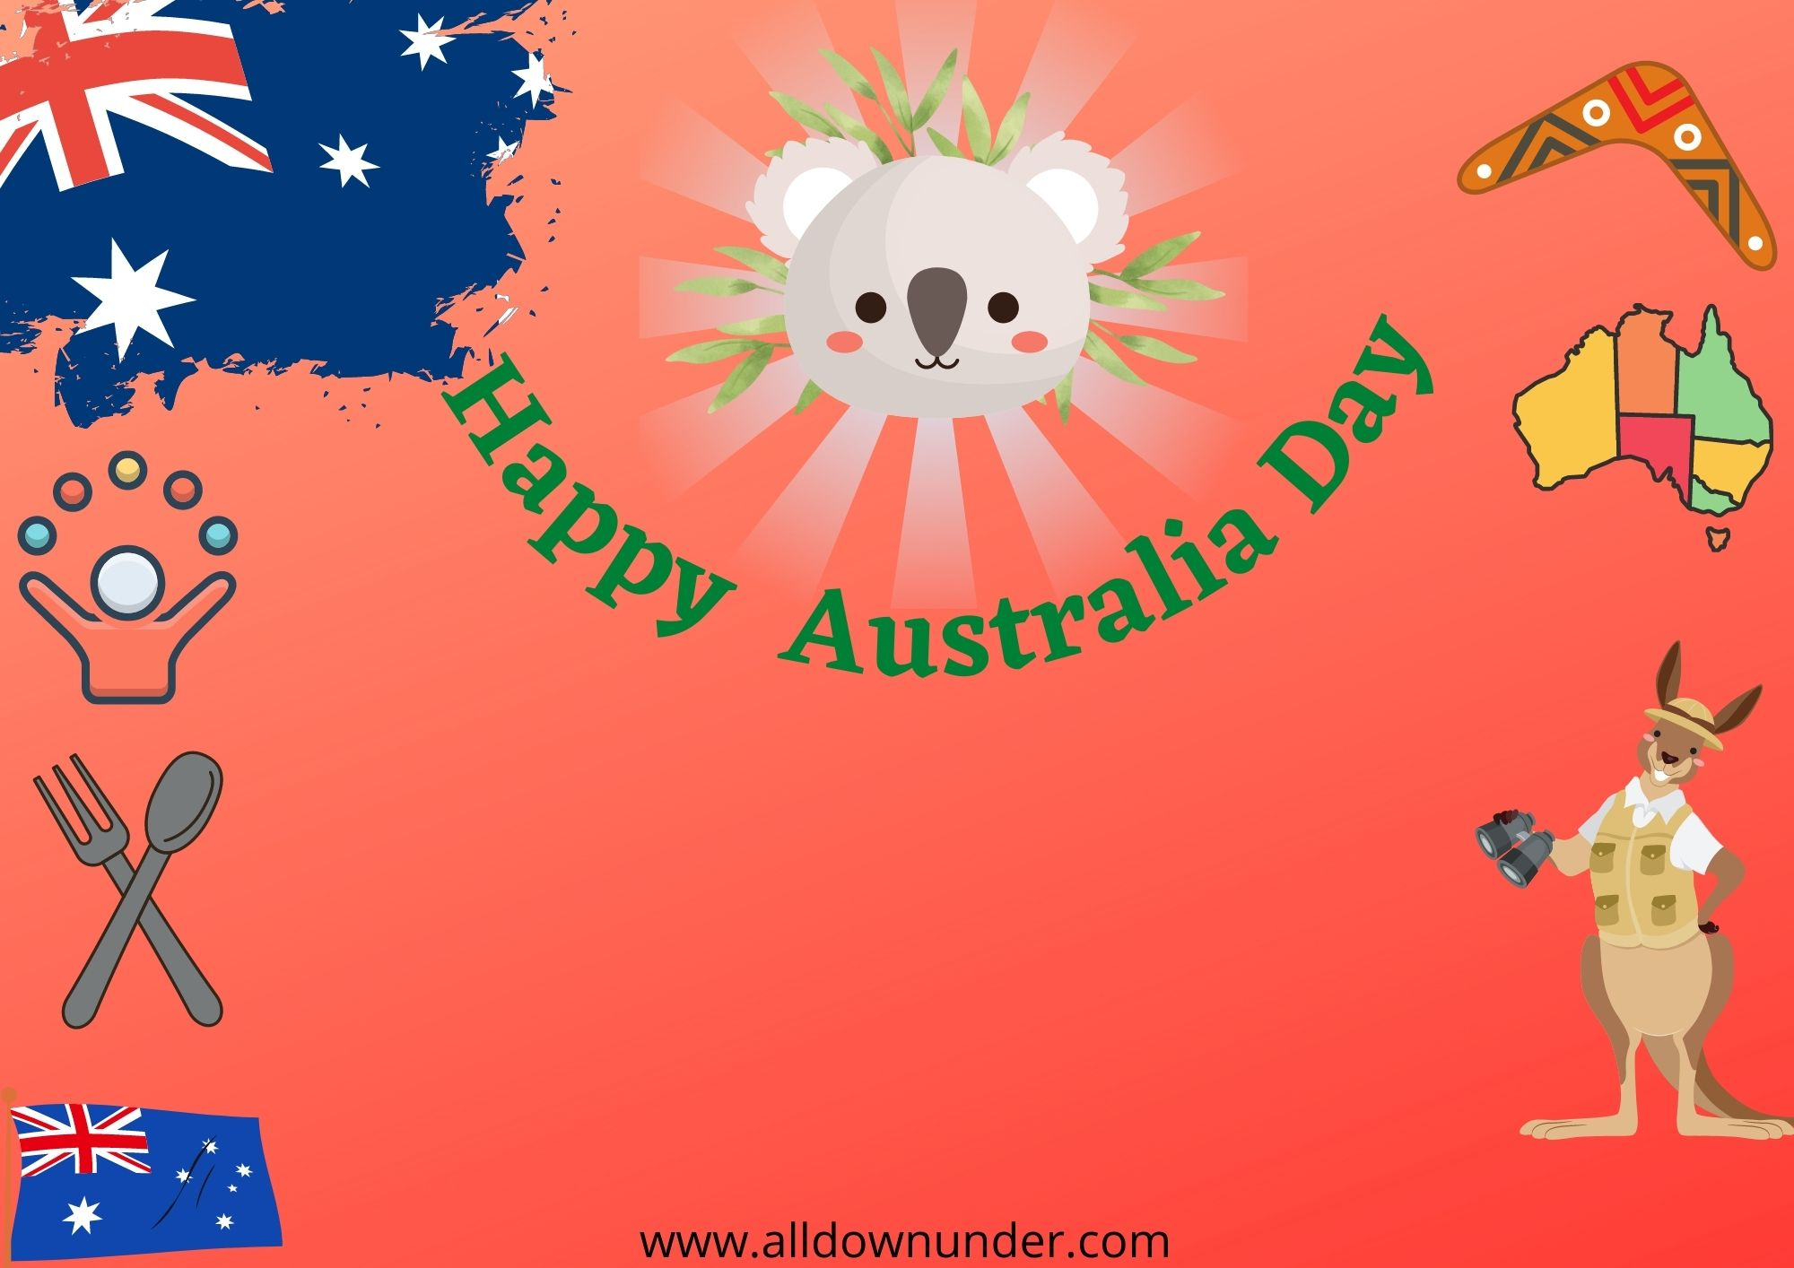

Monday,January 26th

Music|Games|Foods & Drinks

Visit Our Website:www.abc.au.com

1485church Street,Wilora.