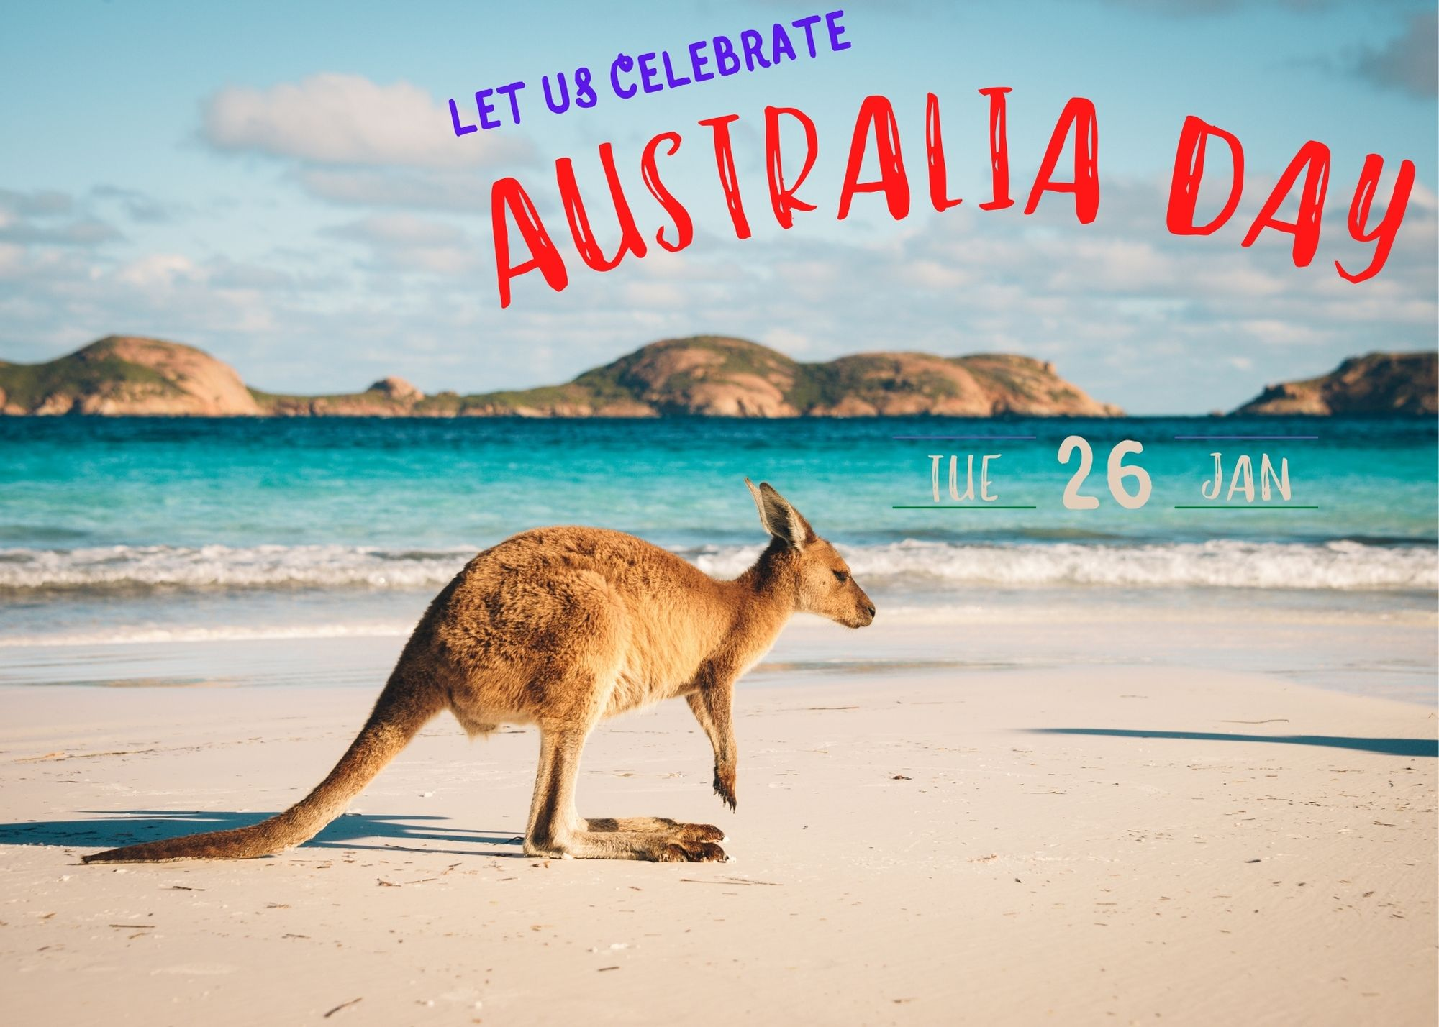

At Australian Park starts at 2 PM

Come and Join us

For Celebrate this Great Day

Charlotte

123456789